**Step 1:**

**Create Log Table in DBAAdmin database:**

USE [DBAAdmin]

GO

/****** Object: Table [dbo].[tbl_UpdateStatLog] Script Date: 7/13/2021 11:59:12 AM ******/

SET ANSI_NULLS ON

GO

SET QUOTED_IDENTIFIER ON

GO

CREATE TABLE [dbo].[tbl_UpdateStatLog](

[rid] [bigint] IDENTITY(1,1) NOT NULL,

[db__name] [varchar](500) NULL,

[cmd] [varchar](max) NULL,

[time_taken] [bigint] NULL,

[createdDate] [datetime] NULL

) ON [PRIMARY] TEXTIMAGE_ON [PRIMARY]

GO

**Step 2:**

**Create USP_UpdateStat_ModifiedRowCountBasis in new User Database**

USE [DB_Name]

GO

/****** Object: StoredProcedure [dbo].[usp_updatestat_ModifiedRowCountBasis] Script Date: 7/13/2021 11:59:43 AM ******/

SET ANSI_NULLS ON

GO

SET QUOTED_IDENTIFIER ON

GO

CREATE proc [dbo].[usp_updatestat_ModifiedRowCountBasis]

@rcnt int

as

set nocount on

delete from dbaadmin..tbl_UpdateStatLog where db__name=db_name(db_id()) and createdDate<=convert(date,dateadd(dd,-2,getdate()))

create table #stat (st_id int identity(1,1), cmd varchar(max))

insert into #stat (cmd)

select

distinct 'update statistics ['+sch.name+'].['+st.name+ '] with fullscan,maxdop=0' cmd

from

sys.tables st

inner join sys.schemas sch on st.schema_id=sch.schema_id

inner join sys.stats ss on st.object_id=ss.object_id

cross apply sys.dm_db_stats_properties(ss.object_id,ss.stats_id) sp

where modification_counter>@rcnt

declare @cnt int, @cmd nvarchar(max), @dt datetime

select @cnt=1

if exists(select 1 from #stat)

begin

while ((select count(1) from #stat ) > 0)

begin

--print 'in'

select @cmd=cmd from #stat where st_id=@cnt

select @dt=getdate()

exec sp_executesql @cmd

print @cmd

insert into dbaadmin..tbl_UpdateStatLog (db__name,cmd,time_taken,createdDate)

select db_name(db_id()),@cmd cmd,datediff(ss,@dt,getdate()) timeTaken_SS,getdate()

delete from #stat where st_id=@cnt

select @cnt=@cnt+1

end

end

else

begin

select 'nothing to update stats'

end

drop table #stat

GO

**Step 3:**

**Create Job and copy following in step 1 of job (Modified_row_count to be discussed and set as per app requirement)**

Create Job with proper naming convention as per RGI Standards: (Refer below screenshot)

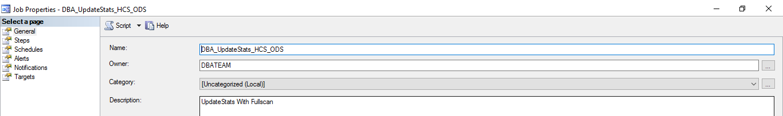

**Job Step:**

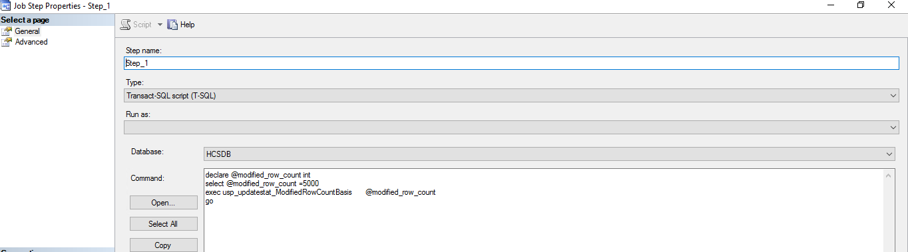

declare @modified_row_count int

select @modified_row_count =10000

exec usp_updatestat_ModifiedRowCountBasis @modified_row_count

go